Warning – Oil Life – CGEA1.3

Functional Description

The purpose of the Oil Life Warnings are to inform the driver that the Engine Oil Change is required or should be changed soon.

Oil_Change_Req_MC_Status_Flag and Oil_Change_Soon_MC_Status_Flag are defined in the Oil Change Minder Function – 10K section of this SPSS.

Interface

Interface Context Diagram (I/O Block Diagram)
Figure 1 Warning – Oil Life Context Diagram
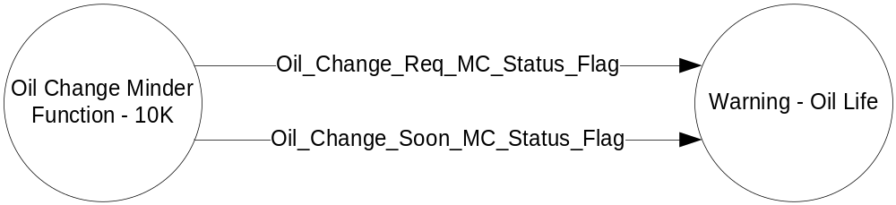

Inputs

- Oil_Change_Req_MC_Status_Flag
- Oil_Change_Soon_MC_Status_Flag

See the Oil Change Minder Function – 10K section of this SPSS for definition of the state of these flags.

Outputs
- Warning Message W70 and W475
For definition of W70 and W475, see the Text Message List section of this SPSS.

Function/Performance

Operational Description

Warning Message W470 shall be Active whenever Oil_Change_Req_MC_Status_Flag = Active
Warning Message W475 shall be Active whenever Oil_Change_Soon_MC_Status_Flag = Active

For definition of how the Message Center arbitrates and displays Active warnings, see the Warning / Alert Display Logic Diagram, located in the Message Center – X Display with W Button Interface section of this SPSS (where X and W are appropriate values in this document).

Table 1 System Check Function for Oil Life Warning
Oil_Change_Req_MC_Status_Flag | Oil_Change_Soon_MC_Status_Flag | Mc SYSTEM CHECK Message ID
INACTIVE | INACTIVE | Skip to next function
ACTIVE | INACTIVE | W470
INACTIVE | ACTIVE | W475
ACTIVE | ACTIVE | W470

SPSS Module Revision History

Revision Level | Name | Change Description | Date
1.0 | V. Patel | Initial release.  Based on CGEA STSS Warning – Oil Life v1.0  No updates required for CGEA1.3 | 5/11/2010

